Department of Computer Science and Engineering
2025-2026
Odd Semester


DATA STRUCTURES AND ALGORITHMS-3
(25CS2103E)

AUTOMATED STUDENT-TO-LABORATORY ALLOCATION USING MAXIMUM BIPARTITE MATCHING

Yashwanth Sai 2520030036
Dhanvin Gupta 2520030604
Naga Pranadeep 2520030390

COURSE INSTRUCTOR

Swathi D
Department of Computer Science and Engineering
AUTOMATED STUDENT-TO-LABORATORY ALLOCATION USING MAXIMUM BIPARTITE MATCHING
1. Introduction
Every semester a department that runs laboratory courses must decide which student attends which lab session. The decision looks simple, but it is a constrained optimisation problem: hundreds of students have preferences for timings, subjects, instructors and peer groups, while every lab session has a limited number of seats, a fixed time slot and its own equipment. When this is done by hand, the result is slow to produce, error-prone, hard to scale and difficult to defend as fair.
This project, carried out for Data Structures and Algorithms-3 (25CS2103E), replaces the manual process with an automated allocation engine. Students and lab sessions are modelled as the two sides of a weighted bipartite graph, and the best possible allocation is obtained with maximum bipartite matching and network-flow techniques. The same idea underlies job placement, course allocation and room scheduling.
2. Problem Statement and Objectives
Given a set of students S, a set of lab sessions L in which session l holds at most c(l) students, and a preference score p(s, l) from 1 to 10 for each acceptable (student, session) pair, find an allocation M that maximises the total preference satisfaction, the sum of p(s, l) over all pairs in M, subject to the constraints below.
Constraint 1. Each student is allocated to at most one lab session, and to exactly one whenever a feasible session exists.
Constraint 2. No lab session receives more students than its capacity c(l).
Constraint 3. A student is never placed in a session whose time slot clashes with a slot in which the student is unavailable.
The objectives of the project are to (i) allocate as many students as possible, ideally close to 100%; (ii) maximise overall preference satisfaction; (iii) keep the distribution of satisfaction across sessions fair; (iv) report transparently any student who cannot be placed; and (v) remain fast and light enough to be used for institution-sized cohorts.
3. Case Study: Lab Allocation in a University Department
3.1 Scenario
Consider a department that runs a lab course for about 1,000 students. The course is delivered in 50 lab sessions spread over five weekly time slots, and each session has between 18 and 24 seats. Every student submits a short ranked list of preferred sessions and also declares the time slots in which they are unavailable because of other classes. The administrator must publish one session per student, with no clashes and no overfull labs.
3.2 Why the manual process fails
Time and errors. Matching hundreds of preference lists against seat counts by hand takes days, and every late change forces the work to be redone.
Conflicting demands. Popular sessions are over-subscribed while others stay half empty; fixing one clash often creates another.
No transparency. Students cannot see why they received a particular session, and the department has no fairness metric to show that the outcome is equitable.
3.3 Worked example
To make the idea concrete, the project includes a small example with eight students (S1 to S8) and four lab sessions, each with two seats: Lab-A (Mon-AM), Lab-B (Mon-PM), Lab-C (Tue-AM) and Lab-D (Tue-PM). Table 1 lists the preferences, written as lab:score. Student S8 is unavailable on Monday afternoon, so the edge from S8 to Lab-B is removed when the graph is built.
Student | Preferences (lab:score) | Unavailable | Greedy (roll order) | Optimal matching
S1 | A:10, B:9 | - | Lab-A (10) | Lab-B (9)
S2 | A:10, B:9, C:5 | - | Lab-A (10) | Lab-A (10)
S3 | A:10, C:7, D:4 | - | Lab-C (7) | Lab-C (7)
S4 | B:10, C:6 | - | Lab-B (10) | Lab-B (10)
S5 | D:10, B:6 | - | Lab-D (10) | Lab-D (10)
S6 | B:10, A:6, D:5 | - | Lab-B (10) | Lab-D (5)
S7 | C:10, D:7 | - | Lab-C (10) | Lab-C (10)
S8 | A:8, B:7 | Mon-PM | UNMATCHED | Lab-A (8)
Total |  |  | 67 (7 placed) | 69 (8 placed)
Table 1. Preferences and the two allocations for the worked example
A simple first-come-first-served strategy serves students in roll order and gives each the best lab that still has a free seat. S1 and S2 take Lab-A, which fills it. S8, who can only attend Lab-A, is left without a session purely because of the order of service. Maximum matching avoids this by finding an augmenting path: S8 takes a seat in Lab-A, S1 is re-routed to Lab-B, which still has space, and everyone is placed. Among all allocations that place all eight students the algorithm then selects the one with the highest total preference, 69 against 67 for the greedy result.
4. Modelling the Problem as a Bipartite Graph
A bipartite graph G = (S, L, E) has two disjoint vertex sets and edges only between them. Here the left set holds the students and the right set holds the lab sessions. An edge (s, l) exists if the student listed session l as acceptable and the slot of l does not clash with the student's unavailable slots; its weight is the preference score p(s, l). Because a lab can take several students, each session l is expanded into c(l) identical seat vertices, so that a one-to-one matching between students and seats corresponds exactly to a valid allocation. A matching is then maximum when it places the largest possible number of students, and a maximum-weight maximum matching is the allocation that also maximises total preference.
Element of the problem | Representation in the model
Student s | Left vertex
Lab session l with capacity c(l) | Right vertex, expanded into c(l) seats (or an edge of capacity c(l) to the sink in the flow network)
Acceptable session for a student | Edge (s, l)
Preference score p(s, l) | Edge weight; cost 10 - p(s, l) in the flow network
Time conflict | Edge not created
Valid allocation | Matching in which no seat is used twice
Table 2. Mapping the allocation problem onto a bipartite graph
5. Theoretical Background
Bipartite matching. A matching is a set of edges without a common endpoint. Berge's lemma states that a matching is maximum if and only if it admits no augmenting path, which is an alternating path between two unmatched vertices. All algorithms used here repeatedly find and flip augmenting paths.
Hall's Marriage Theorem. All students on the left can be matched if and only if every subset X of students has at least |X| neighbouring seats. If the theorem's condition fails, the algorithm will necessarily leave some student unmatched, which is why the unmatched list is reported rather than hidden.
Hopcroft-Karp. Finds a maximum cardinality matching in O(E sqrt(V)) time by augmenting along many shortest, vertex-disjoint paths in each phase, and is used here to establish how many students can possibly be placed.
Hungarian algorithm. The classic O(n^3) solution to the weighted assignment problem. It is used in the project as an independent check of optimality.
Maximum flow and minimum-cost flow. Matching is a special case of flow. Ford-Fulkerson and Dinic's algorithm give efficient large-scale solutions, and successive shortest paths on a cost network gives the maximum-weight allocation with capacities handled directly.
Fairness-aware assignment. Recent models balance satisfaction against constraints. In this project fairness is measured by the spread of the average preference score across lab sessions.
6. Tools and Technologies
The allocation engine is written in Python 3 and uses only the standard library (heapq, collections, statistics, tracemalloc); SciPy is used only to cross-check optimality with its Hungarian solver. The project presentation also describes a deployment design with SQLite or PostgreSQL storage, a Flask/Django web dashboard for administrators and a REST API for existing systems; the code in this report implements the core allocation engine that such a system would call.

ALGORITHM / PSEUDO CODE
1. Overview
The solution runs in four phases. Phase 1 builds the weighted bipartite graph from the student preferences and time conflicts. Phase 2 runs Hopcroft-Karp to compute the maximum number of students that can be placed at all. Phase 3 runs a minimum-cost maximum-flow algorithm to choose, among all maximum allocations, the one with the highest total preference. Phase 4 validates every constraint, computes the quality metrics and reports unmatched students. The pseudo code of each phase is given below; line numbers refer to the explanation that follows.
Algorithm 1: BUILD-GRAPH(Students, Labs)
1 for each lab l in Labs: create c(l) seat vertices (implicit)
2 for each student s in Students:
3 adj[s] <- empty list
4 for each (l, p) in prefs[s]:
5 if slot(l) not in busy[s]: // time-conflict constraint
6 append (l, p) to adj[s]
7 return adj

Algorithm 2: HOPCROFT-KARP(adj, Labs) -- maximum placements
1 seat_adj[s] <- all seats of every lab in adj[s]
2 matchL[*] <- NIL ; matchR[*] <- NIL ; size <- 0
3 repeat
4 BFS: put free students at layer 0; extend layers alternately
5 student -> seat -> student matched to that seat
6 if the BFS reaches no free seat: break
7 for each free student u:
8 if DFS(u) finds a layered augmenting path:
9 flip matched/unmatched edges along the path
10 size <- size + 1
11 until no augmenting path exists
12 return size

Algorithm 3: MAX-WEIGHT-ASSIGNMENT(adj, Labs)
1 build network: source -> student (cap 1, cost 0)
2 student -> lab (cap 1, cost 10 - p(s, l))
3 lab -> sink (cap c(l), cost 0)
4 pot[v] <- 0 for every vertex v
5 loop
6 Dijkstra from source on residual edges, reduced cost
7 cost(u, v) + pot[u] - pot[v]
8 if sink is unreachable: break
9 pot[v] <- pot[v] + dist[v] for every reachable v
10 push one unit of flow along the shortest source -> sink path
11 student s is assigned to lab l iff the edge s -> l is saturated

Algorithm 4: VALIDATE(assign) and ALLOCATE(Students, Labs)
1 for each assigned pair (s, l):
2 check slot(l) not in busy[s] and l in prefs[s]
3 for each lab l: check load(l) <= c(l)
4 report violations and the list of unmatched students

5 ALLOCATE(Students, Labs):
6 adj <- BUILD-GRAPH(Students, Labs)
7 bound <- HOPCROFT-KARP(adj, Labs)
8 assign <- MAX-WEIGHT-ASSIGNMENT(adj, Labs)
9 VALIDATE(assign) ; report metrics ; return assign

2. Step-by-Step Explanation
Step 1 - Graph construction (Algorithm 1). Each student's ranked list is turned into edges. Any edge whose lab slot appears in the student's unavailable set is skipped, so time conflicts can never appear in the final result. Cost: one pass over all preferences, O(E).
Step 2 - Maximum matching (Algorithm 2). Every lab is expanded into c(l) seats. A breadth-first search layers the free students, a depth-first search then walks only along layered edges to find vertex-disjoint augmenting paths, and all paths found in a phase are flipped together. Phases repeat until the search finds no free seat. The returned size is the largest number of students any allocation can place; no algorithm can do better under the given preference lists.
Step 3 - Optimisation (Algorithm 3). The same graph is cast as a flow network with a source, the students, the labs and a sink. Using cost 10 - p(s, l) turns maximising preference into minimising cost. Successive shortest paths with Dijkstra and vertex potentials push one unit of flow at a time; because each augmentation is the cheapest available, the final flow places the maximum number of students at minimum total cost. Saturated student-to-lab edges are read off as the allocation.
Step 4 - Output and validation (Algorithm 4). The allocation mapping is checked against the constraints, load per lab is counted, and the unmatched students are listed. The same allocation is also compared with the Hungarian method from SciPy on an expanded cost matrix as an independent optimality test.
3. Trace on the Worked Example
For the eight-student example, Phase 1 creates 18 edges (the S8-to-Lab-B edge is dropped because of the Monday-afternoon clash). Hopcroft-Karp reports a maximum of 8 placements, so a complete allocation exists. A first-come-first-served pass would give S1 and S2 the two seats of Lab-A and leave S8 with no option. The flow algorithm discovers the augmenting path S8 - Lab-A - S1 - Lab-B: S8 takes a seat in Lab-A, S1 moves to Lab-B, which still has a free seat, and all eight students are placed. Phase 3 then chooses S6 for the last seat in Lab-D (score 5) because Lab-B is full, giving the final total of 69. The validation step confirms that every lab is exactly full (2/2) and that no constraint is violated.
4. Correctness
Maximum size. By Berge's lemma a matching is maximum when no augmenting path exists. Hopcroft-Karp terminates only when its search finds none, and min-cost flow stops only when the sink is unreachable in the residual graph, so both phases return the maximum number of placements.
Optimal weight. Successive shortest paths keeps the invariant that the current flow has minimum cost among all flows of its size, because the residual graph never contains a negative cycle under the potentials. The final flow is therefore a minimum-cost maximum flow, which is a maximum-preference maximum matching.
Constraint safety. Capacity is enforced by the lab-to-sink edge (and by the number of seats), the one-session rule by the capacity-1 source edge, and time conflicts by never creating the corresponding edge. The validation step re-checks all three.
5. Complexity Analysis
Phase | Time | Space
1. Graph construction | O(E) | O(V + E)
2. Hopcroft-Karp (seat graph) | O(E' sqrt(V')), V' = n + sum c(l), E' = sum of c(l) over edges | O(V' + E')
3. Min-cost max-flow | O(F E log V), F <= n students | O(V + E)
4. Validation and metrics | O(n + |L|) | O(|L|)
Table 3. Complexity of each phase (V = students + labs, E = acceptable edges)
The simple augmenting-path method for general matching costs O(V E); Hopcroft-Karp improves this to O(E sqrt(V)). The dominant cost of the full pipeline is Phase 3, whose cost grows with both the number of augmentations F and the size of the graph, which the scalability results confirm.

CODE
File: lab_allocation.py Run: python lab_allocation.py [demo | bench | all]
"""
Automated Student-to-Laboratory Allocation using Maximum Bipartite Matching
DSA-3 (25CS2103E) - PBL
Team: Yashwanth Sai (2520030036), Dhanvin Gupta (2520030604),
Naga Pranadeep (2520030390)
Course Instructor: Swathi D

Pipeline
Phase 1 Graph construction : students (left) - lab seats (right), weighted edges
Phase 2 Maximum matching : Hopcroft-Karp -> largest possible number of placements
Phase 3 Optimization : min-cost max-flow -> highest total preference
Phase 4 Output + validation : mapping, constraint checks, unmatched report
"""
import heapq
import random
import statistics
import sys
import time
import tracemalloc
from collections import deque

MAX_SCORE = 10 # preference scores are on a 1..10 scale

# --------------------------------------------------------------------------
# Data model
# --------------------------------------------------------------------------
class Student:
def __init__(self, sid, name, prefs, busy=()):
self.sid, self.name = sid, name
self.prefs = dict(prefs) # lab_id -> preference score p(s, l)
self.busy = set(busy) # time slots in which the student is unavailable

class Lab:
def __init__(self, lid, name, slot, capacity):
self.lid, self.name, self.slot, self.capacity = lid, name, slot, capacity

# --------------------------------------------------------------------------
# Phase 1 - graph construction
# --------------------------------------------------------------------------
def build_graph(students, labs):
"""adj[i] = list of (lab_index, score); edges that clash in time are dropped."""
lab_index = {lab.lid: j for j, lab in enumerate(labs)}
adj = []
for st in students:
edges = []
for lid, score in st.prefs.items():
j = lab_index[lid]
if labs[j].slot not in st.busy: # constraint 3: time conflicts
edges.append((j, score))
adj.append(edges)
return adj

# --------------------------------------------------------------------------
# Phase 2 - Hopcroft-Karp on the seat graph (each lab expanded into c(l) seats)
# --------------------------------------------------------------------------
def hopcroft_karp(adj, labs):
seats, seat_lab = [], [] # seat -> lab index
first_seat = []
for j, lab in enumerate(labs):
first_seat.append(len(seat_lab))
seat_lab.extend([j] * lab.capacity)
n, m = len(adj), len(seat_lab)
seat_adj = [[s for (j, _) in adj[i]
for s in range(first_seat[j], first_seat[j] + labs[j].capacity)]
for i in range(n)]
INF = float("inf")
match_l, match_r = [-1] * n, [-1] * m

def bfs():
dist = [INF] * n
q = deque(i for i in range(n) if match_l[i] == -1)
for i in q:
dist[i] = 0
found = False
while q:
u = q.popleft()
for v in seat_adj[u]:
w = match_r[v]
if w == -1:
found = True
elif dist[w] == INF:
dist[w] = dist[u] + 1
q.append(w)
return found, dist

def dfs(u, dist): # iterative DFS (no recursion limit)
stack, path = [(u, iter(seat_adj[u]))], []
while stack:
node, it = stack[-1]
advanced = False
for v in it:
w = match_r[v]
if w == -1: # free seat: augment along the path
path.append((node, v))
for (a, b) in path:
match_l[a], match_r[b] = b, a
return True
if dist[w] == dist[node] + 1:
path.append((node, v))
stack.append((w, iter(seat_adj[w])))
advanced = True
break
if not advanced:
dist[node] = INF
stack.pop()
if path:
path.pop()
return False

size = 0
while True:
found, dist = bfs()
if not found:
break
for i in range(n):
if match_l[i] == -1 and dfs(i, dist):
size += 1
return size

# --------------------------------------------------------------------------
# Phase 3 - maximum preference among maximum matchings (min-cost max-flow)
# source -> student (cap 1, cost 0)
# student -> lab (cap 1, cost MAX_SCORE - p(s, l))
# lab -> sink (cap c(l), cost 0)
# --------------------------------------------------------------------------
def max_weight_assignment(adj, labs):
n, k = len(adj), len(labs)
S, T = n + k, n + k + 1
graph = [[] for _ in range(n + k + 2)] # edge = [to, cap, cost, rev_index]

def add(u, v, cap, cost):
graph[u].append([v, cap, cost, len(graph[v])])
graph[v].append([u, 0, -cost, len(graph[u]) - 1])

for i in range(n):
add(S, i, 1, 0)
for (j, score) in adj[i]:
add(i, n + j, 1, MAX_SCORE - score)
for j, lab in enumerate(labs):
add(n + j, T, lab.capacity, 0)

N, pot = len(graph), [0] * len(graph) # Johnson potentials (costs >= 0)
while True:
dist, prev = [float("inf")] * N, [None] * N
dist[S] = 0
pq = [(0, S)]
while pq:
d, u = heapq.heappop(pq)
if d > dist[u]:
continue
for idx, (v, cap, cost, _) in enumerate(graph[u]):
nd = d + cost + pot[u] - pot[v]
if cap > 0 and nd < dist[v]:
dist[v], prev[v] = nd, (u, idx)
heapq.heappush(pq, (nd, v))
if dist[T] == float("inf"):
break
for v in range(N):
if dist[v] < float("inf"):
pot[v] += dist[v]
v = T
while v != S: # push one unit along the shortest path
u, idx = prev[v]
graph[u][idx][1] -= 1
graph[v][graph[u][idx][3]][1] += 1
v = u

assign = [None] * n
for i in range(n):
for (v, cap, _, _) in graph[i]:
if n <= v < n + k and cap == 0: # saturated student->lab edge
assign[i] = v - n
return assign

# --------------------------------------------------------------------------
# Phase 4 - validation and metrics
# --------------------------------------------------------------------------
def validate(students, labs, assign):
problems, load = [], [0] * len(labs)
for i, j in enumerate(assign):
if j is None:
continue
load[j] += 1
if labs[j].slot in students[i].busy:
problems.append(f"{students[i].name}: time conflict in {labs[j].name}")
if labs[j].lid not in students[i].prefs:
problems.append(f"{students[i].name}: {labs[j].name} not in preference list")
for j, lab in enumerate(labs):
if load[j] > lab.capacity:
problems.append(f"{lab.name}: capacity exceeded ({load[j]}/{lab.capacity})")
return problems, load

def metrics(students, labs, assign):
scores = [students[i].prefs[labs[j].lid] for i, j in enumerate(assign) if j is not None]
per_lab = [[] for _ in labs]
for i, j in enumerate(assign):
if j is not None:
per_lab[j].append(students[i].prefs[labs[j].lid])
lab_means = [statistics.mean(x) for x in per_lab if x]
placed = len(scores)
return {
"placed": placed,
"students": len(students),
"rate": 100.0 * placed / len(students),
"total": sum(scores),
"avg": statistics.mean(scores) if scores else 0.0,
"lab_std": statistics.pstdev(lab_means) if len(lab_means) > 1 else 0.0,
}

def allocate(students, labs):
adj = build_graph(students, labs) # Phase 1
upper_bound = hopcroft_karp(adj, labs) # Phase 2
assign = max_weight_assignment(adj, labs) # Phase 3
return adj, upper_bound, assign

def greedy(students, labs):
"""Baseline: students served in roll order, each takes best free feasible lab."""
adj, left = build_graph(students, labs), [lab.capacity for lab in labs]
assign = [None] * len(students)
for i, edges in enumerate(adj):
for (j, _) in sorted(edges, key=lambda e: -e[1]):
if left[j] > 0:
assign[i], left[j] = j, left[j] - 1
break
return assign

def verify_with_scipy(students, labs, adj, assign):
"""Independent optimality check using the Hungarian method (SciPy)."""
try:
import numpy as np
from scipy.optimize import linear_sum_assignment
except ImportError:
return None
n = len(students)
seat_lab = [j for j, lab in enumerate(labs) for _ in range(lab.capacity)]
BIG = 10 ** 6
cost = np.full((n, len(seat_lab) + n), BIG, dtype=np.int64)
for i in range(n):
for (j, score) in adj[i]:
for s, lab_j in enumerate(seat_lab):
if lab_j == j:
cost[i, s] = MAX_SCORE - score
cost[i, len(seat_lab):] = BIG # "unassigned" dummy columns
r, c = linear_sum_assignment(cost)
best = int(cost[r, c].sum())
ours = sum(MAX_SCORE - students[i].prefs[labs[j].lid] if j is not None else BIG
for i, j in enumerate(assign))
return ours == best, ours, best

# --------------------------------------------------------------------------
# Demo data (small, human-readable) and benchmark generator
# --------------------------------------------------------------------------
SLOTS = ["Mon-AM", "Mon-PM", "Tue-AM", "Tue-PM"]

def demo_data():
labs = [Lab("A", "Lab-A", "Mon-AM", 2), Lab("B", "Lab-B", "Mon-PM", 2),
Lab("C", "Lab-C", "Tue-AM", 2), Lab("D", "Lab-D", "Tue-PM", 2)]
raw = [("S1", {"A": 10, "B": 9}, ()),
("S2", {"A": 10, "B": 9, "C": 5}, ()),
("S3", {"A": 10, "C": 7, "D": 4}, ()),
("S4", {"B": 10, "C": 6}, ()),
("S5", {"D": 10, "B": 6}, ()),
("S6", {"B": 10, "A": 6, "D": 5}, ()),
("S7", {"C": 10, "D": 7}, ()),
("S8", {"A": 8, "B": 7}, ("Mon-PM",))]
return [Student(i, n, p, b) for i, (n, p, b) in enumerate(raw)], labs

def benchmark_data(n_students=1000, n_labs=50, seed=42):
rnd = random.Random(seed)
slots = [f"slot{k}" for k in range(5)]
labs = [Lab(f"L{j}", f"Lab-{j + 1:02d}", slots[j % 5], rnd.randint(18, 24))
for j in range(n_labs)]
weights = [1.0 / (j + 3) ** 0.6 for j in range(n_labs)] # some labs are more popular
students = []
for i in range(n_students):
picks = []
while len(picks) < 3:
j = rnd.choices(range(n_labs), weights)[0]
if j not in picks:
picks.append(j)
scores = sorted((rnd.randint(7, 10), rnd.randint(4, 8), rnd.randint(1, 5)),
reverse=True)
prefs = {labs[j].lid: s for j, s in zip(picks, scores)}
busy = {rnd.choice(slots)} if rnd.random() < 0.25 else set()
students.append(Student(i, f"S{i + 1:04d}", prefs, busy))
return students, labs

# --------------------------------------------------------------------------
# Reports
# --------------------------------------------------------------------------
def run_demo():
students, labs = demo_data()
adj, bound, assign = allocate(students, labs)
base = greedy(students, labs)
print("=" * 66)
print(" DEMO: 8 students, 4 labs (capacity 2 each)")
print("=" * 66)
print(f"{'Student':<8}{'Allocated lab':<16}{'Slot':<10}{'Score':>6} {'Greedy':>8}")
for i, st in enumerate(students):
j = assign[i]
g = base[i]
gs = f"{labs[g].name}" if g is not None else "-"
if j is None:
print(f"{st.name:<8}{'UNMATCHED':<16}{'-':<10}{'-':>6} {gs:>8}")
else:
print(f"{st.name:<8}{labs[j].name:<16}{labs[j].slot:<10}"
f"{st.prefs[labs[j].lid]:>6} {gs:>8}")
m, mg = metrics(students, labs, assign), metrics(students, labs, base)
problems, load = validate(students, labs, assign)
print("-" * 66)
print(f"Hopcroft-Karp maximum placements : {bound} of {len(students)}")
print(f"Optimal total preference : {m['total']} (avg {m['avg']:.2f}/10)")
print(f"Greedy baseline total preference : {mg['total']} "
f"({mg['placed']} of {len(students)} placed)")
print("Lab load : " +
", ".join(f"{lab.name} {load[j]}/{lab.capacity}" for j, lab in enumerate(labs)))
status = "PASSED" if not problems else "; ".join(problems)
print(f"Constraint check : {status}")
ok = verify_with_scipy(students, labs, adj, assign)
if ok:
print(f"Hungarian (SciPy) cross-check : {'OPTIMAL' if ok[0] else 'MISMATCH'}")

def run_benchmark(n_students=1000, n_labs=50):
students, labs = benchmark_data(n_students, n_labs)
t0 = time.perf_counter() # timing run (no tracing overhead)
adj, bound, assign = allocate(students, labs)
elapsed = time.perf_counter() - t0
tracemalloc.start() # separate run to measure peak memory
allocate(students, labs)
_, peak = tracemalloc.get_traced_memory()
tracemalloc.stop()
m = metrics(students, labs, assign)
base = metrics(students, labs, greedy(students, labs))
problems, load = validate(students, labs, assign)
unmatched = [students[i].name for i, j in enumerate(assign) if j is None]
print("=" * 66)
print(f" BENCHMARK: {n_students} students, {n_labs} lab sessions "
f"(total seats {sum(l.capacity for l in labs)})")
print("=" * 66)
print(f"Edges in bipartite graph : {sum(len(a) for a in adj)}")
print(f"Hopcroft-Karp maximum placements : {bound}")
print(f"Students allocated : {m['placed']} / {m['students']}"
f" ({m['rate']:.1f}%)")
print(f"Average preference satisfaction : {m['avg']:.2f} / 10")
print(f"Std. dev. of lab mean score : {m['lab_std']:.2f}"
f" ({100 * m['lab_std'] / m['avg']:.1f}% of mean)")
print(f"Total preference (optimal) : {m['total']}")
print(f"Total preference (greedy) : {base['total']}"
f" (placed {base['placed']})")
print(f"Allocation runtime : {elapsed * 1000:.0f} ms")
print(f"Peak memory (tracemalloc) : {peak / 1024 / 1024:.1f} MB")
print(f"Unmatched students : {len(unmatched)}")
status = "PASSED" if not problems else f"{len(problems)} violations"
print(f"Constraint check : {status}")
ok = verify_with_scipy(students, labs, adj, assign)
if ok:
print(f"Hungarian (SciPy) cross-check : {'OPTIMAL' if ok[0] else 'MISMATCH'}")

if __name__ == "__main__":
mode = sys.argv[1] if len(sys.argv) > 1 else "all"
if mode in ("demo", "all"):
run_demo()
if mode in ("bench", "all"):
if mode == "all":
print()
run_benchmark()

RESULTS
1. Console Output: Worked Example
The following output is produced by running python lab_allocation.py demo. The right-hand column shows the lab given to each student by the greedy baseline; S8 is left unmatched by the baseline but placed by maximum matching.
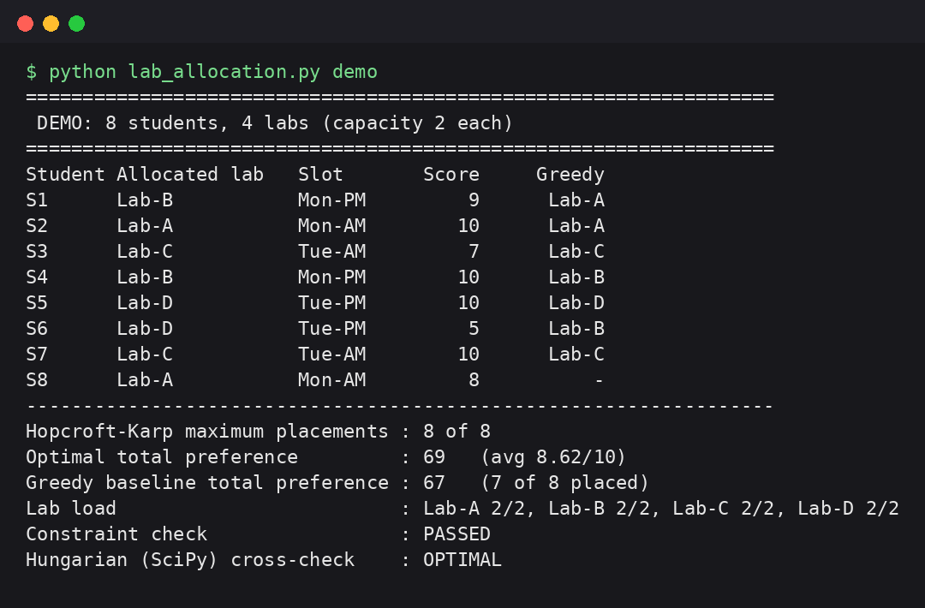
Figure 1. Allocation of the eight-student example (matching vs greedy baseline)
2. Console Output: 1,000 Students and 50 Lab Sessions
The benchmark uses a fixed random seed (42): 50 sessions over five slots with 18 to 24 seats each (1,035 seats in total), students with three ranked choices and a 25% chance of one unavailable slot.
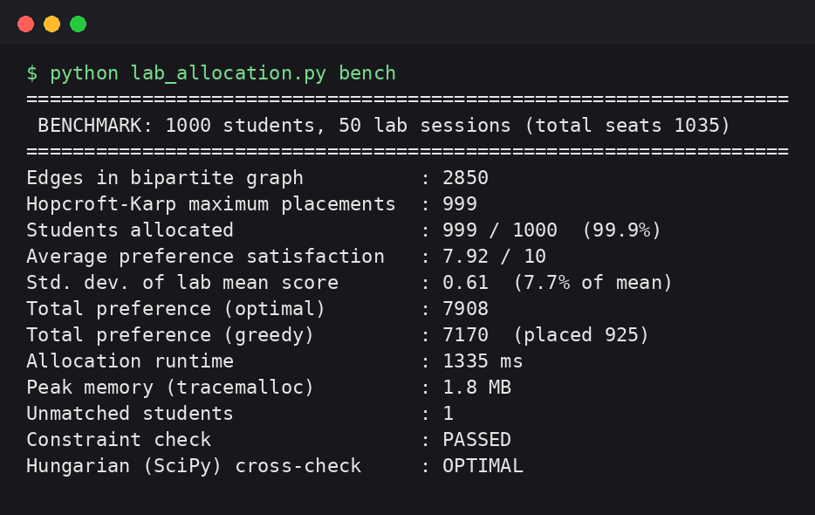
Figure 2. Benchmark run with 1,000 students
3. Summary of Results
Metric (1,000 students, 50 sessions) | Result
Students allocated | 999 of 1,000 (99.9%)
Maximum possible placements (Hopcroft-Karp) | 999
Average preference satisfaction | 7.92 / 10
Std. deviation of the mean score across labs | 0.61 (7.7% of the mean)
Total preference: optimal vs greedy | 7,908 vs 7,170
Students placed: optimal vs greedy | 999 vs 925
Allocation runtime | about 1.3 seconds
Peak memory (Python allocations) | 1.8 MB
Constraint validation | Passed, no violations
Hungarian (SciPy) cross-check | Optimal
Table 4. Benchmark results
Scalability
Students | Lab sessions | Edges | Placed | Runtime (approx.)
250 | 13 | 716 | 250 (100%) | 0.09 s
500 | 25 | 1,420 | 500 (100%) | 0.29 s
1,000 | 50 | 2,850 | 999 (99.9%) | 1.3 s
2,000 | 100 | 5,682 | 1,998 (99.9%) | 7.0 s
Table 5. Effect of problem size (same generator, same seed)
4. Analysis
Quality. The algorithm placed 999 of 1,000 students. This equals the Hopcroft-Karp bound, so the single unmatched student could not have been placed by any allocation under the submitted preference lists and time conflicts. All capacity, one-session and time-conflict checks passed, and the Hungarian cross-check confirmed that the total preference is optimal.
Benefit over a simple strategy. First-come-first-served placed only 925 students and obtained a total preference of 7,170, whereas the matching-based allocation placed 999 students with a total of 7,908.
Fairness. The mean score of individual lab sessions varies with a standard deviation of 0.61 points (7.7% of the overall mean of 7.92), so no session is systematically disadvantaged.
Performance. A complete allocation for 1,000 students takes about 1.3 seconds on a standard machine and uses very little memory. Runtime grows faster than linearly with the number of students (about 80 times slower for 8 times more students), consistent with the O(F E log V) cost of the flow phase. For larger cohorts the flow phase could be sped up by starting from the Hopcroft-Karp matching or by augmenting along many paths per Dijkstra pass.
5. Conclusion
Maximum bipartite matching gives a mathematically sound way to allocate students to laboratory sessions: it places every student that can be placed, maximises preference satisfaction, respects capacity and time constraints, and is verified against an independent algorithm. It removes the manual effort and makes the outcome transparent and fair. Future work includes machine-learning-based preference prediction, dynamic real-time re-allocation, multi-objective optimisation with instructor workload, a mobile application, cross-institution lab sharing and richer constraints such as prerequisites and peer groups.
Note: the figures above come from running lab_allocation.py (seed 42) on generated data; runtimes vary slightly between runs and machines.

